Kidzone
Preschool & Childcare
Located on Lake Michigan College Campus, B-Wing
Room
“Kidz on Kampus”
June 10 - August 16, 2024
8:00a.m. – 5:00 p.m. M-TH
Proudly serving school age children since 2001.

How To Register:
Limited Space !

“K I D Z O N K A M P U S”
Kidzone 2024 Summer Camp Program

“Kidz on Kampus” is a great summertime program for school-aged children featuring themed camps, special topics, bi-weekly field trips and more! This is a terrific opportunity to bring your children to LMC and to keep them actively learning while having fun!
- Bi-weekly themed camps run for 10 weeks during the summer.
- Sign up for one camp week or for the entire summer.
- For children who have completed Kindergarten up to age 10.
How to Register

- Complete online registration form at: www.kidzoneonline.com
- Call (269) 927-6293 or register in person at LMC Kidzone Preschool & Childcare Center
- Kidzone Preschool & Childcare located at 2755 East Napier Avenue, Benton Harbor, MI 49022
- For more information send email to:
karla.pepple@kidzoneonline.com

Make some summer memories at Kidzone!

- Monday through Thursday, 8:00a.m.-5:00p.m. (limited extended care).
- Children will be given a camp water bottle for daily use and a camp shirt for trips. Both are theirs to keep when camp ends.
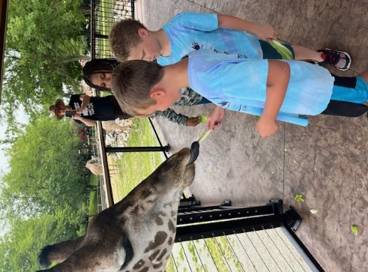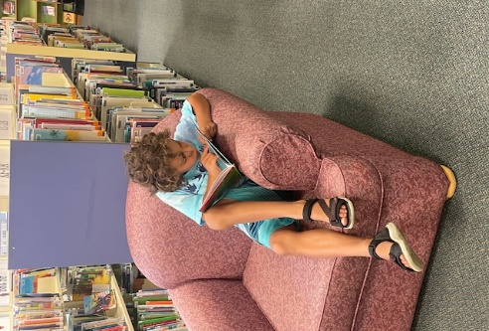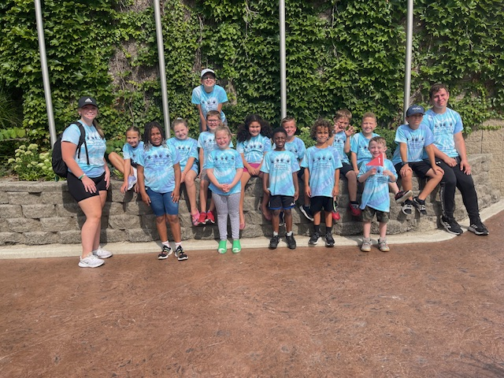

Tuition and Fees
- $50 registration fee per child
- $75 registration fee per family
- $175.00 tuition per week (FT)
- $60.00 per scheduled day (PT)
- Fees for off campus field trips
- DHS Assistance accepted.
- Limited extended care

Payments are due bi-weekly on Mondays in advance. We offer Tuition Express for convenience.
Activities

- Weekly Themes
- On/Off Campus Field Trips
- Arts & Crafts
- Outdoor/Indoor Games
- Water Fun
- Breakfast and afternoon snack provided daily.
- Movie days
- Math and Reading enrichment.
- And much more!

What to bring daily

- Sunscreen
- Tennis shoes
- Lunch w/ice pack and drink.

Kidzone Will Provide
- A Water Bottle for daily use
- Camp T-shirt (for off campus field trip days)

Student Name:

Child’s Date of Birth: Child’s Gender: Child’s Shirt Size_______________
Home Phone: Main Contact Number:
Street Address: City: State: Zip:
City: State: Zip:

Mother’s Name: Mother’s Email:
Cell Phone: Cell Carrier: Father’s Name: Father’s Email:
Cell Phone: Cell Carrier:
How are you associated with LMC? (circle) Student Staff Community
I, declare that my school-aged child ,
^{(Parent/Guardian name)} ^{(Child’s name)}
is in good health, has all shots up-to date, and on record in the administration office. (Please list any medical restrictions below)

Medical Restrictions:
I give my child permission to use gym, computer lab, LMC classroom and go on walks on the campus of Lake Michigan College. I also give permission to Kidzone to take pictures of my children to use for Facebook, and marketing purposes.

^{(Signature)} ^{Date}

A family handbook with outlined policies and procedures is available upon request and online at www.kidzoneonline.com .
“Kidz on Kampus” Summer Camp Registration Form

